ALLANSON STREET PRIMARY SCHOOL

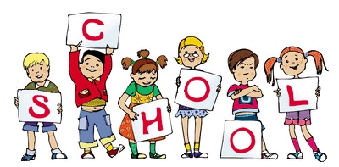

Children in Years 5 (age 9 – 10) and 6 (age 10 – 11) are in the upper juniors. During their time with us, we work incredibly hard to help them reach their full potential both academically and on a personal level, with a view to preparing them for their transition to high school and the future world of work.
In this booklet, you will find all of the information you will need to understand the learning journey your child is on, as well as how you can best support them.

General Information

Structure of the day
Generally, each morning consists of writing, reading and maths lessons. Afternoons are when we undertake topic lessons, PE, ICT, RE and PSHE. Please note that a new timetable will be sent home each half term. This will include information regarding the days your child will have P.E and require their P.E kits etc. as well as which projects we will be undertake.
Staff
Below is a list of the adults that your child will work alongside in the upper juniors.
Miss Matthews – Year 6 Class Teacher / Department Leader
Miss Kellett – Year 6 Class Teacher
Mrs Lea – Year 6 Teacher
Mrs Rooney – Year 6 Support Assistant
Mrs Wall – Year 6 Support Assistant
Mrs Owen - Year 6 Support Assistant
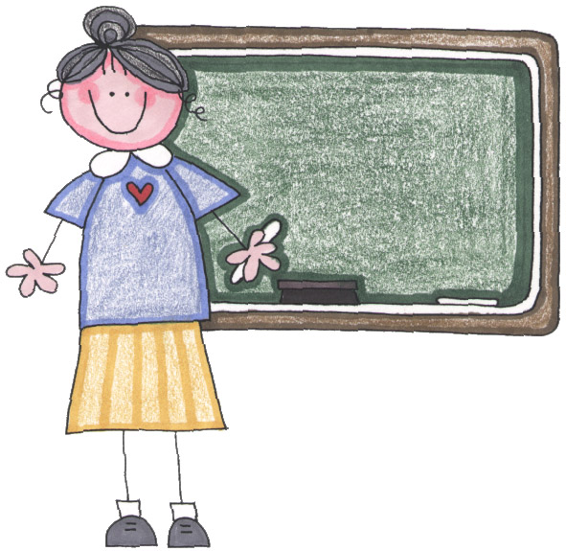
Mrs Green - Year 6 Support Assistant
Miss Slater - Year 6 Support Assistant
Mr Regan – Year 5 Class Teacher
Mrs Onyett – Year 5 Class Teacher
Mrs Doolan - Year 5 Support Assistant
Mrs Grotzka - Year 5 Support Assistant
Miss Wilmitt - Year 5 Support Assistant
We are all extremely committed to providing your child with the best possible education as well as helping them to continue to grow into happy, confident young people. As such we would love for you to be as involved as much as possible in your child’s schooling. With this in mind, we are available at the end of every school day, when we see the children out onto the playground, should you wish to speak to us. If you would like to talk to us in more depth over a specific issue, you can, of course, make an appointment either at the school office or when you see us on the playground.


Parents Meetings
Each year, we schedule 2 individual meetings with parents / carers. These take place week in the Autumn and Spring terms. During these meetings we will update you on your child’s progress as well as give you an opportunity to voice any concerns and ask questions etc.

Uniform
All children are expected to wear the correct school uniform.

If for any reason your child can not wear a piece of their uniform, we would appreciate a note from you to reassure us that you are aware of the situation and to inform us of when we can expect to see your child back in their full school uniform. Children wearing incorrect uniform, including trainers, without a note should expect to lose dojos which children earn to access our termly treat (see ‘Behaviour’). Please note: Children are allowed to wear trainers on the playground as long as they change back into their school shoes at the end of break.

Snack Time
During first break, our Year 6 children run a healthy snack shop which all junior children can access. The snacks range in price from 15p to 30p. Children are also welcome to bring their own healthy snacks from home.

Learning
Lessons / Projects
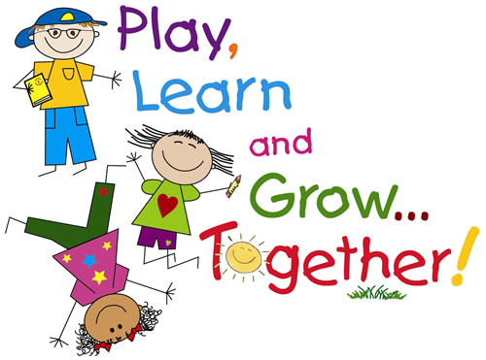
In the Upper Juniors we put all of our time and effort into making learning as fun, interesting, relevant and accessible, for all of our children, as possible. With this in mind, we plan various exciting projects each year. Our first projects, ‘Pitter Patter Raindrops’ (Y6) and Ancient Greece (Y5), will really start our year off with a bang. Keep a look out at the beginning of each half term for your ‘Curriculum Newsletter’ which will tell you all about our new projects, including opportunities for you to get involved and share your child’s success.

Assessment
During the school year, your child will participate in an assessment week each of the three terms. During these weeks your child will be assessed in each area of the curriculum to ascertain their progress and highlight areas for development for the coming term.
In Year 6, the 3rd assessment week is replaced by SATs week, w/c 10.05.21. This works quite differently as the children undertake very important national tests called SAT’s. This is when the children will undertake tests in Mathematics and English. Later this year, parents / carers of our Year 6 children will be invited to a meeting to give them more information about SATs.
In our everyday teaching and learning, children are made aware of the progress they have made and encouraged to identify how they can improve even further. This allows them to feel pride in what they have achieved and recognise what they need to do to move forward. It also helps them to take some responsibility for their own learning.

Visitors and outings
A large part of making the children’s learning completely engaging is the fact that we utilise a range of visitors and out of school trips to help bring learning to life and to provide our children with fun ways to celebrate new learning. Again, keep a look out for your half term curriculum newsletters for information regarding upcoming trips and visitors.

Trips
At the end of Year 6, our children have the opportunity to go on a 3 night trip to York. Further information about this will be sent home to parents / carers of Y6 children in September. Children who do not wish to go to York will spend the same three days going on exciting day trips.
At the end of the year, Year 5 have the opportunity to go on the Gold Trip. This is a free trip which children, who have earned 300 dojos or more throughout the year, are given the opportunity to attend. In previous years, this has been a trip to Southport where the children go bowling, visit a park and are treated to a lunch of fish and chips.

Year 6 Production
Each year our Year 6 children work incredibly hard to put on their own fabulous production. This takes place after SATs and is a real showcase of our children’s fantastic talents.

Behaviour
In Years 5 and 6 we have the very highest expectations of the children in terms of following our school code of conduct, and as such invest a great deal of encouraging our children to be the very best they can be.
We use a behaviour points system called ‘Class Dojo’ throughout school. This web based program allows staff to award dojos for positive behaviours and remove points for behaviours that need improvement. Every dojo we award or take off is linked to our 8 school values: respect, independence, kindness, pride, integrity, resilience, aspiration and courage. As well as collecting dojo points for certificates and termly treats, the child in each class who earn the most dojos each week, will be invited to the Dojo Café with Mrs Dingsdale on a Friday afternoon.

If at any point we have any concerns about a child’s behaviour, we will always contact their parent / carer to make sure we work together to help that child to make better choices in future. Whenever a child makes a poor behaviour choice, time is always taken to talk to him / her to find out the reasons for their choice, to make sure they understand why their behaviour was not appropriate and talk about how they can make better choices next time.

Staying in Touch


As ClassDojo has been such a fantastic resource in keeping in touch with the children over the period of home learning, we want to continue this form of communication throughout the school. We will be using the ClassDojo app to keep in touch with parents to: promote any learning outside of school, share any celebratory moments and maintain general contact. Mrs. Dingsdale will reveal further information regarding this closer to September.

Termly treats

Termly treats are activities which take place each term to reward those children who consistently behave well. The ability to earn these treats is linked very closely to our dojo system. To be allowed to take part in the termly treat, children must have earned 100 dojos throughout the term. Our first treat this year is a toy day which will take place on Friday 18th December 2020.

How you can help your child

As we’re sure you are all too aware, it will seem like no time at all before your child is heading off to high school. With this in mind, one of the best ways you can help your child is to encourage them to be as independent as possible. This includes ensuring your child now comes into school on their own every morning and takes responsibility for bringing their own equipment to school.

Home Learning
Your child will receive a piece of Maths and a piece of English homework every Thursday (Y5) and Thursday (Y6). This must be returned by the following Tuesday or a penalty of 1 point will be deducted from your child’s dojo account. We strongly advise encouraging your child to do their home learning as soon as they get it, as not only will the information be fresher in their minds but it will also give them a chance to bring it back into school, should they require further help, without the home learning being returned late.
Home Learning Kits
We will be giving every child their own ‘Home Learning Kit’ to make working at home as easy as possible. This will include every piece of equipment they could possibly need to complete their given home learning activities.
We expect these kits to last for the rest of your child’s time at our school. To keep them safe, all kits will predominantly ‘live’ in school as they will be given out, and must return, with the home work each week. Should your child lose any items from their kit, we will expect them to replace it at a small cost from our stationery shop which will be open during lunch times.

If you have any questions about any of the information contained in this booklet, please feel free to speak to your child’s class teacher at the end of the school day.

We really do value and appreciate your support.

Very best wishes,
The Upper Junior Team

