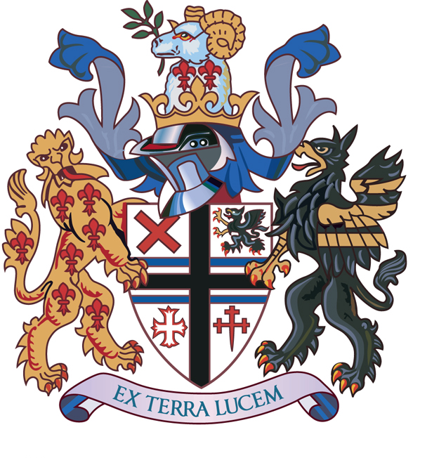

St. Helens Council
Children’s Services Directorate
Atlas House
Corporation Street
St Helens
Merseyside
WA9 1LD
Contact: Jim Leivers
Tel: 01744 671802
JimLeivers@sthelens.gov.uk
Our ref 14052020/JL
Your ref

14th May 2020

Dear Parents and Carers

We are writing to you all to update you on the Government’s recent announcement and conditional plans for schools opening to more children and young people.

Since 23rd March schools have remained open only to children of critical workers and vulnerable children. Following the Prime Minister’s announcement on Sunday evening, schools will potentially open for children and young people in specific year groups from 1st June.

The Government have asked all Primary schools to open for all children in Nursery, Reception, Year 1 and Year 6.

Secondary schools, sixth forms, and further education colleges will begin some face to face support with Year 10 and Year 12 pupils, although it is not expected that these pupils will return on a full-time basis at this stage.

All schools will continue to remain open for children of critical workers and vulnerable children in all year groups.

Some of you will rightly remain concerned about the safety of your children and your families if your children do return to school. The latest scientific advice to the Government is that:

- There is high scientific confidence that children of all ages have less severe symptoms than adults if they contract coronavirus and there is moderately high scientific confidence that younger children are less likely to become unwell if infected with Coronavirus.

- Limiting the numbers of children going back to school and college initially then gradually increasing numbers, guided by scientific advice, reduces risk of increasing the rate of transmission.

With this advice central to the Government’s decision, the Department for Education has provided advice to school leaders on the steps they should take as they plan for reopening, which includes:

- Carrying out a risk assessment before opening to more children - the assessment will directly address risks associated with coronavirus so that sensible measures can be put in place to minimise those risks for children and staff.
- Making sure that children and young people do not attend if they or a member of their household has symptoms of Coronavirus.
- Promoting regular hand washing for 20 seconds and ensuring good respiratory hygiene by promoting the ‘Catch it, Bin it, Kill it’ approach.
- Cleaning more frequently to get rid of the virus on frequently touched surfaces, such as door handles, handrails, table tops, play equipment and toys.
- Minimising contact through smaller classes or group sizes and altering the environment as much as possible, such as changing the layout of classrooms.
- Reducing mixing between groups through timetable changes, such as staggered break and lunch times and by introducing staggered drop-off and collection times at different times.

The Government is encouraging children in the eligible year groups to attend, unless they are self-isolating or there are other reasons for absence (such as shielding due to health conditions). Unfortunately, siblings in different year groups, unless those siblings are children of critical workers or vulnerable children, will not be able to attend at this time.

Parents will not be fined for their children’s non-attendance during these arrangements.

The Government has produced further information for parents and carers. This information provides answers to a number of key questions, including:

- Why can more children now attend school and childcare settings?
- What does the latest scientific advice say?
- Can my child return to school?
- What if my child is eligible but has siblings who are not?
- How will risks to children, teachers and families be managed?
- If my child is eligible, is it compulsory for them to attend school?
- Do all vulnerable children and young people who are not currently attending have to go back to childcare settings, school or college now?
- Should I keep my child at home if they have an underlying health condition or live with someone in a clinically vulnerable group?
- Can children be tested for the virus?
- What happens if there is a confirmed case of coronavirus in my child’s school, college or childcare setting?
- Will education be provided as normal to children and young people who are attending?
- How should my child travel to and from their childcare, school or college?
- Will school meals be available for children and young people who are in school? • Will childcare, schools and colleges keep their usual opening hours?

You can find the detailed answers to these questions by following the link: https://www.gov.uk/government/publications/closure-of-educational-settings-information-forparents-and-carers/reopening-schools-and-other-educational-settings-from-1-june

Headteachers and their Governing Bodies are currently working tirelessly to consider the Government’s recent advice and guidance. They are undertaking risk assessments, putting robust plans into place and making the necessary changes to ensure that their schools can open safely for the identified groups of children, young people and staff.

This will take time and we thank you for your patience. As soon as Headteachers are in a position to share further information with you about their plans for opening, they will.

Every school is different and, as a result, arrangements in every school will be unique to their individual circumstances. The priority for us and for all school leaders is the safety of your children.

Yours sincerely
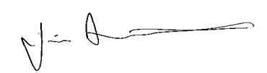

Jim Leivers
Interim Director of Children’s Services

