Project Work
This half term we will be completing our ‘What a Wonderful World’ project learning about the countries of the UK and their capital cities/landmarks. Then focusing on our seaside resorts past and present while learning about their key physical and human geographical features. This will be followed by exploring the wider world, specifically its oceans and different continents.

Physical Development
This half term, P.E sessions take place on Tuesday and Wednesday afternoons. Y2LB will have their lessons on Tuesdays and Y2MM on Wednesdays.
Whilst autumn 1 is a lovely half term for our Year 2 children, it is also a very busy one!
Please read on to learn what the children will be covering this term, and most importantly all the ways you can help them. Thank you.

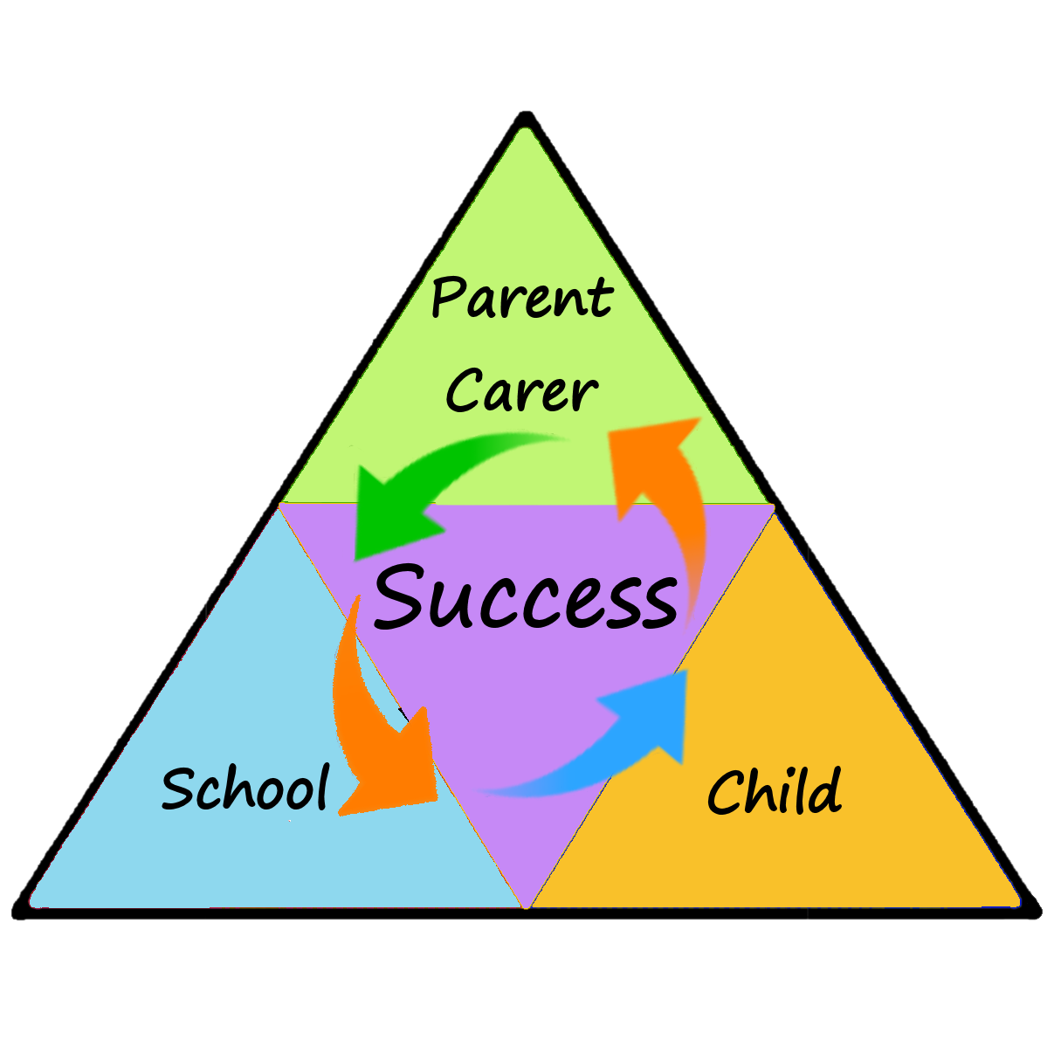
Maths
This half term, the children will reinforce and develop their understanding of number and place value. We will also be developing their reasoning skills, particularly focussing on place value and 2D/ 3D shapes.

English
During English sessions this half term we will be focusing on learning how to use nouns, Proper nouns, adjectives and verbs correctly in our writing. Following this, we will work on writing our own story which includes these.
Reading skills will be taught during small group guided reading and phonics sessions. We are also introducing daily spelling practise in class and the word lists the children use will be sent home for extra reinforcement.
How you can help
We will aim to give every child in Year 2 a new reading book by the end of next week. If you could make sure your child brings their book bag containing their current reading book and reading record to school every day this would be a HUGE help.
Encouraging your child to practise their weekly spelling lists will support their confidence and fluency when writing.
Our maths work will focus mainly on number therefore discussing numbers in everyday life will really benefit the children e.g. which amount/quantity is more/less, can they beat their current gaming score? How much by? How will they know?

Year 2
Autumn 1
Newsletter
ICT
This term, we will be working on Internet safety and improving word processing skills.
General Information/
Dates for your Diary
KS1 snack money is £1.50 per week payable each week in class. To encourage children’s independence, where possible, please put this in an envelope with their name on and ask your child to pass it on to Miss Byron (2MM) or Mrs Helsby (2LB).
Saying goodbye to your child at the school doors or in the KS1 cloakroom will also encourage their independence and help with vital health and safety as our corridor does become very congested each morning. However, if you do need to speak to a member of staff please feel free to do so at the beginning or end of the school day.

PHSE
Our focus this half term will be

