Theme for the term
This half term we will be thinking primarily about Starting School and finding out more about each other through traditional stories eg Goldilocks and the 3 bears – we will look at families. The 3 little pigs – we will look at our houses.

This term is a lovely half term for our Nursery children, it is also a very busy one as they get to know new friends and some have never left their parents before. Please read on to learn what we will be covering this term, and most importantly all the ways you can help. Please get involved as much as you can.
Personal, Social and Emotional Development
This term we are supporting the children with their play skills and interactions with other children. We are encouraging independence in putting on aprons, choosing resources and tidying them up afterwards! We are also supporting families with the toilet training of their children.

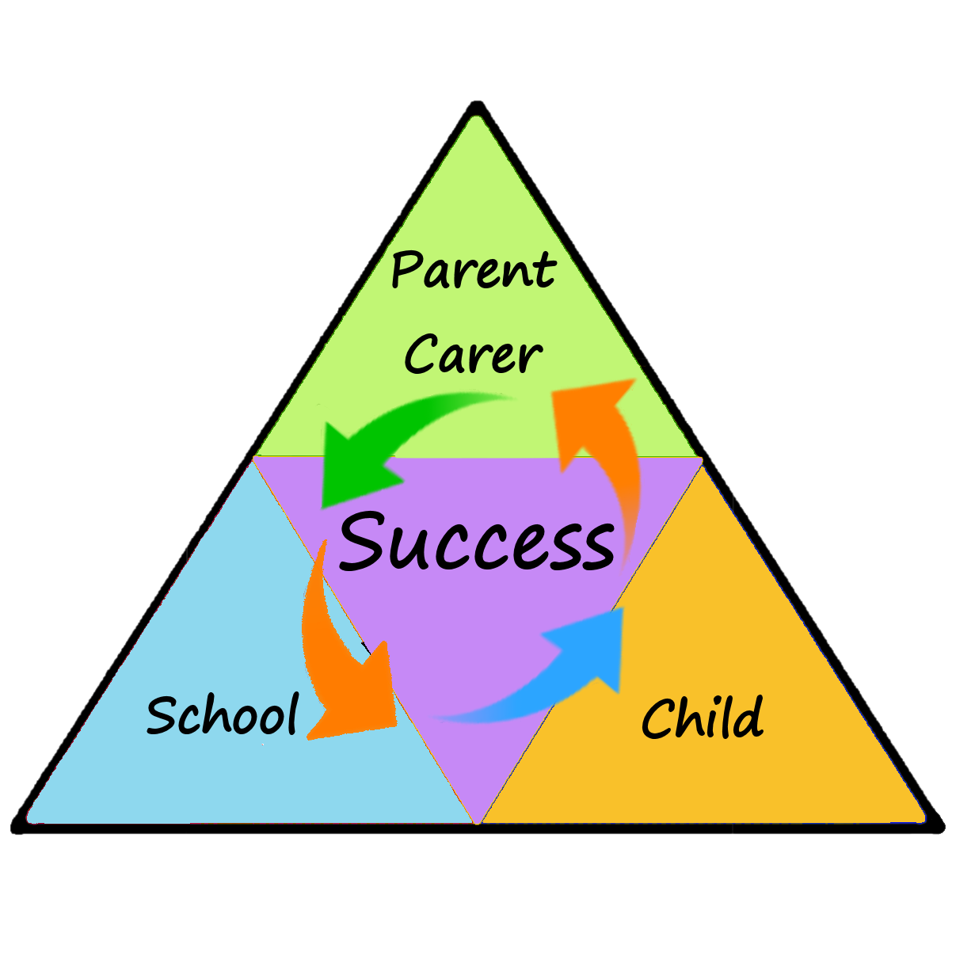
Maths
This half term, the children will be singing lots of number songs and practising counting using lots of different resources – cookies on the plate, bears in the story etc. We are also exploring size and size language.
Literacy
During this term we are reading lots of stories to the children and asking them to use the puppets to retell the story. We are encouraging them to look at books in the Reading area independently and sharing books with an adult. We have started to use our Early Years library where they can choose a book to bring home for the week. We are exploring making marks with pens, pencils, in sand and porridge oats.
Physical Development
This half term we are encouraging the children to use the outdoor equipment safely. We are looking at where they are up to with their fine motor skills and directing them to suitable activities to develop these skills.
How you can help
Please encourage your child to be as independent as they can be, hanging up their own coat in Nursery as they arrive (they may still need a little help) Using the toilet and pulling up their own trousers also.
Read their school library book to them and encourage them to think about the story and characters. If you have not done so already join the local library.
Use number names regularly with children, counting socks into the washing machine, counting stairs as you climb them. Sing Nursery rhymes, we use a lot of songs from Youtube which the children love.
Ask them what they have been learning about at Nursery; everything they do is a learning opportunity especially when they are just playing!
Nursery
Autumn 1
Newsletter
Communication & Language
We are developing language skills all the time as adults support children in their interactions. The stories that we are reading have repeated parts which we encourage the children to join in with; therefore helping with their language development.

Understanding the World
This half term, the children will be encouraged to talk about their experiences during the Summer. They have been talking about their families also.

